**Use Address(Text) in smartforms**

For the initial steps to create a smart form, please refer the previous demos.

1. Create a smart form .

2) Double click on Global Definitions and declare the following.

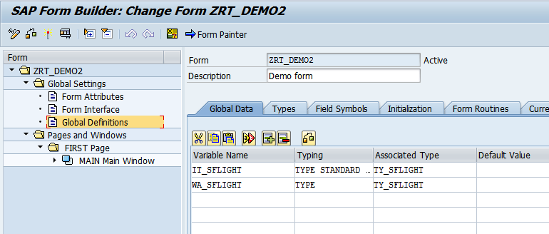

1. In the Types tab , declare the following.
2. TYPES : BEGIN  OF ty_sflight,  
             carrid TYPE s_carr_id,  
             connid TYPE s_conn_id,  
             fldate TYPE s_date,  
             price  TYPE s_price,  
           END OF ty_sflight.

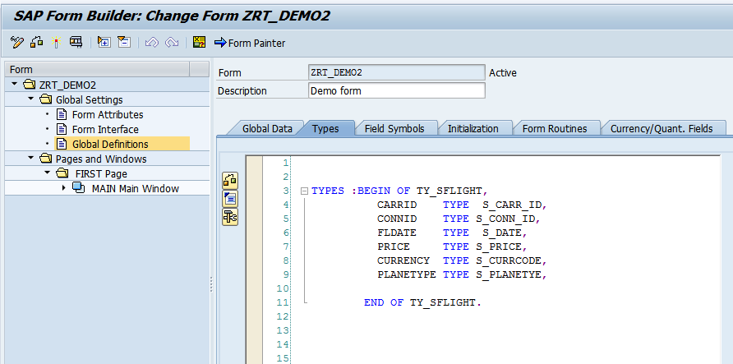

4) Right click on Main window.  
 Create-FlowLogic-ProgramLines

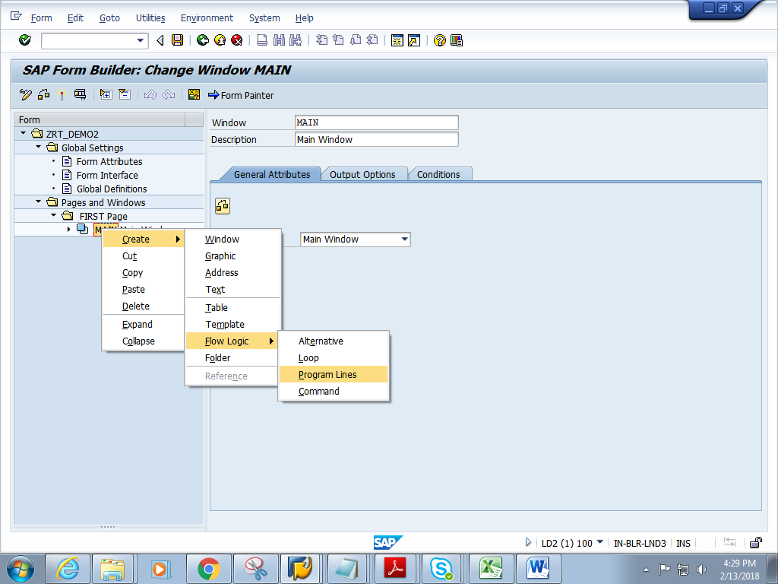

5) Double click on the code1.Give short description.

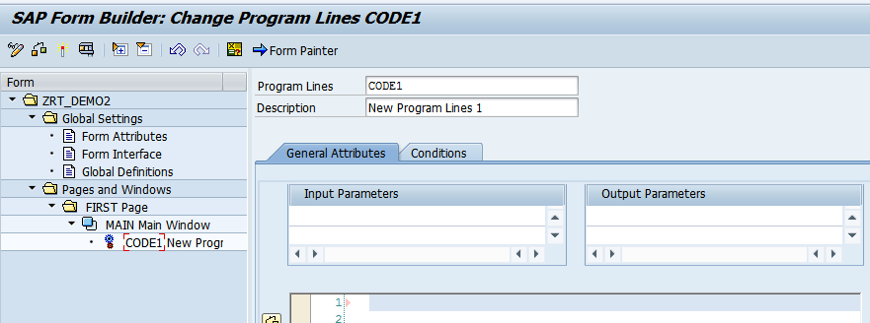

6) Add the below logic. Give the Input and output parameters as shown.

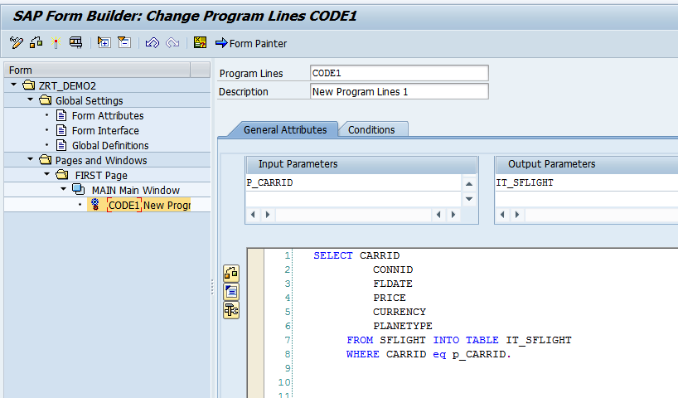

7) Right click on CODE1. Create->FlowLogic->Loop.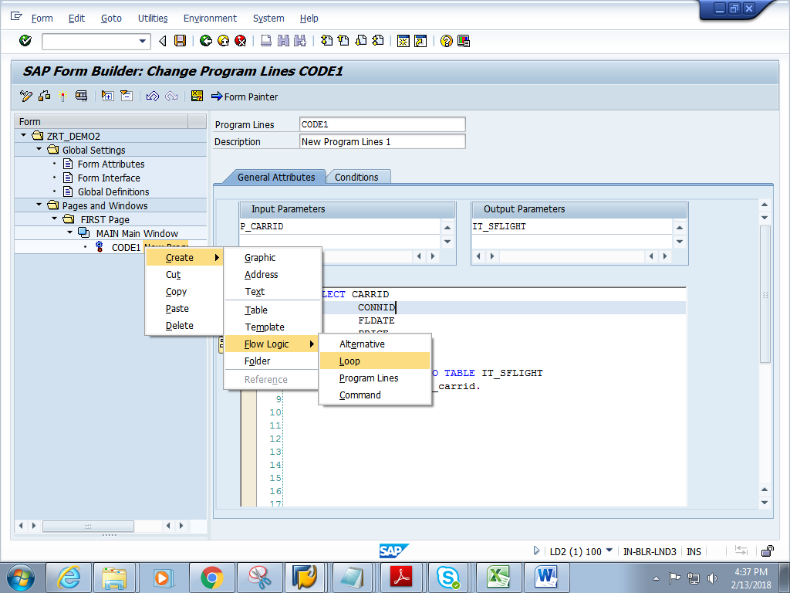

8) Double click on LOOP1 .Give the internal table and work area names.

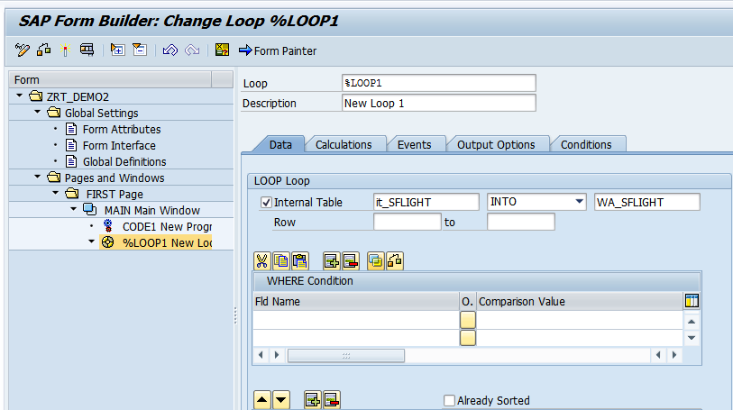

6) Right click onLOOP1.Create->Text.

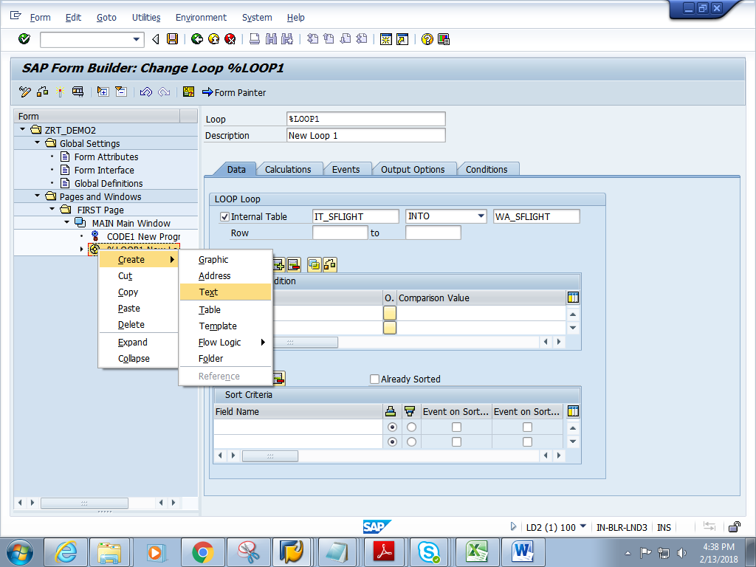

7) Click on the editor

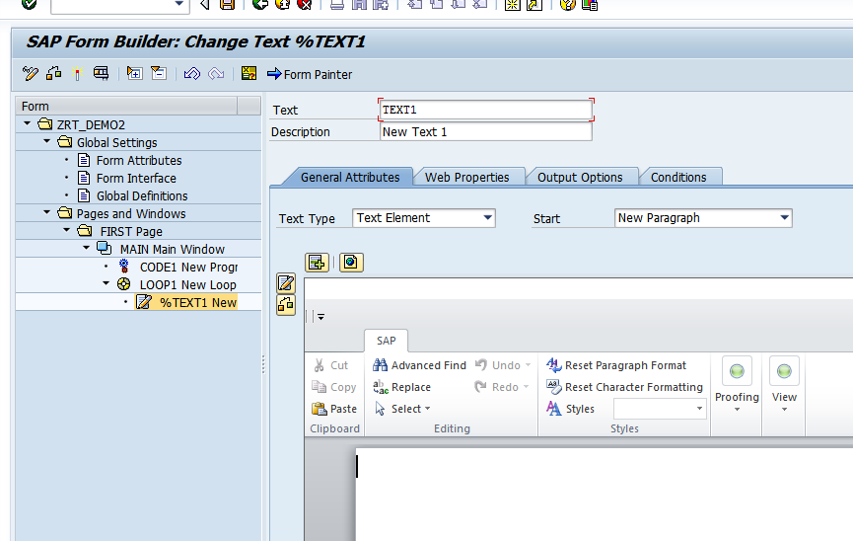

8) Goto-Change Editor

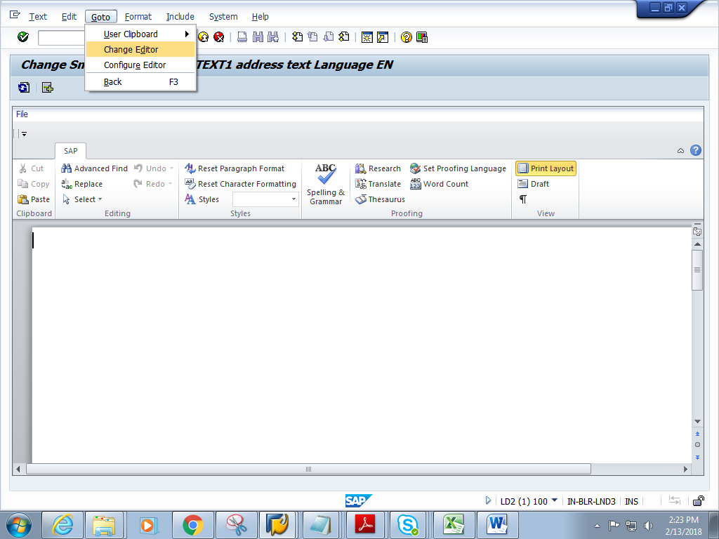

9) Enter the following. Click on Back button

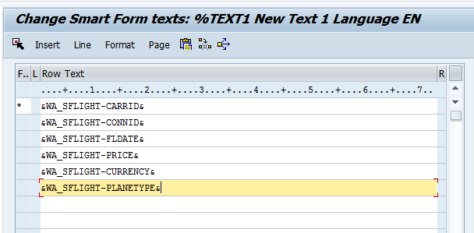

10 ) Click on Form Painter. Adjust the Main window by dragging it and place it in suitable position.

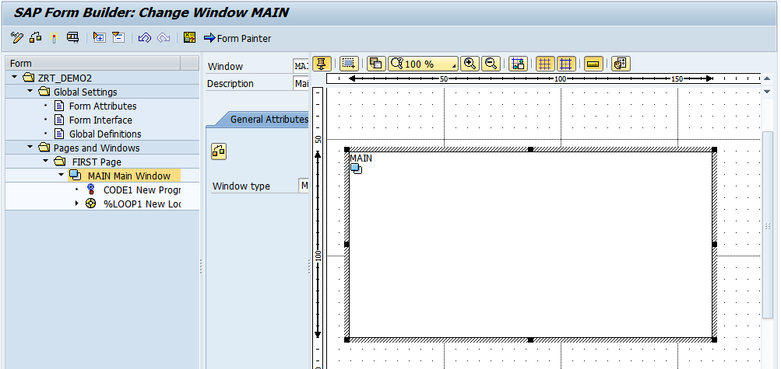

11) Save and activate the form.

12) Execute the form .Execute the function module. **Give the name of the CARRID**.

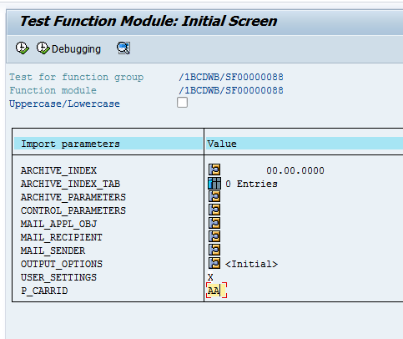

13) Click on Print preview

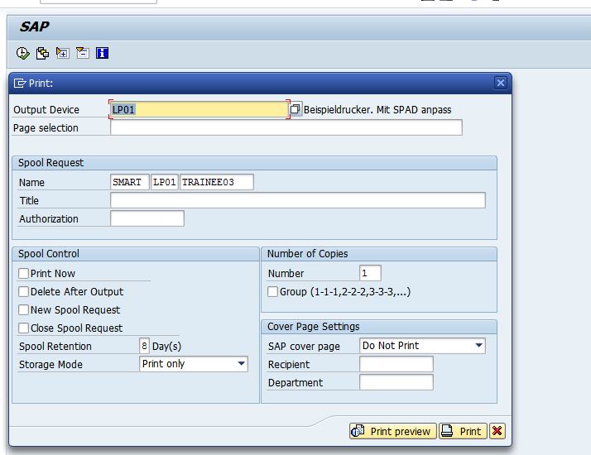

14) Expected output is as follows.

